Lab Exercise 20
App Deployment Using ECS And ECR

Step 1: Create ECR Repository
- Go to AWS Console
- Search Elastic Container Registry (ECR)
- Click Create Repository
- Give name (example: my-web-app)
- Click Create

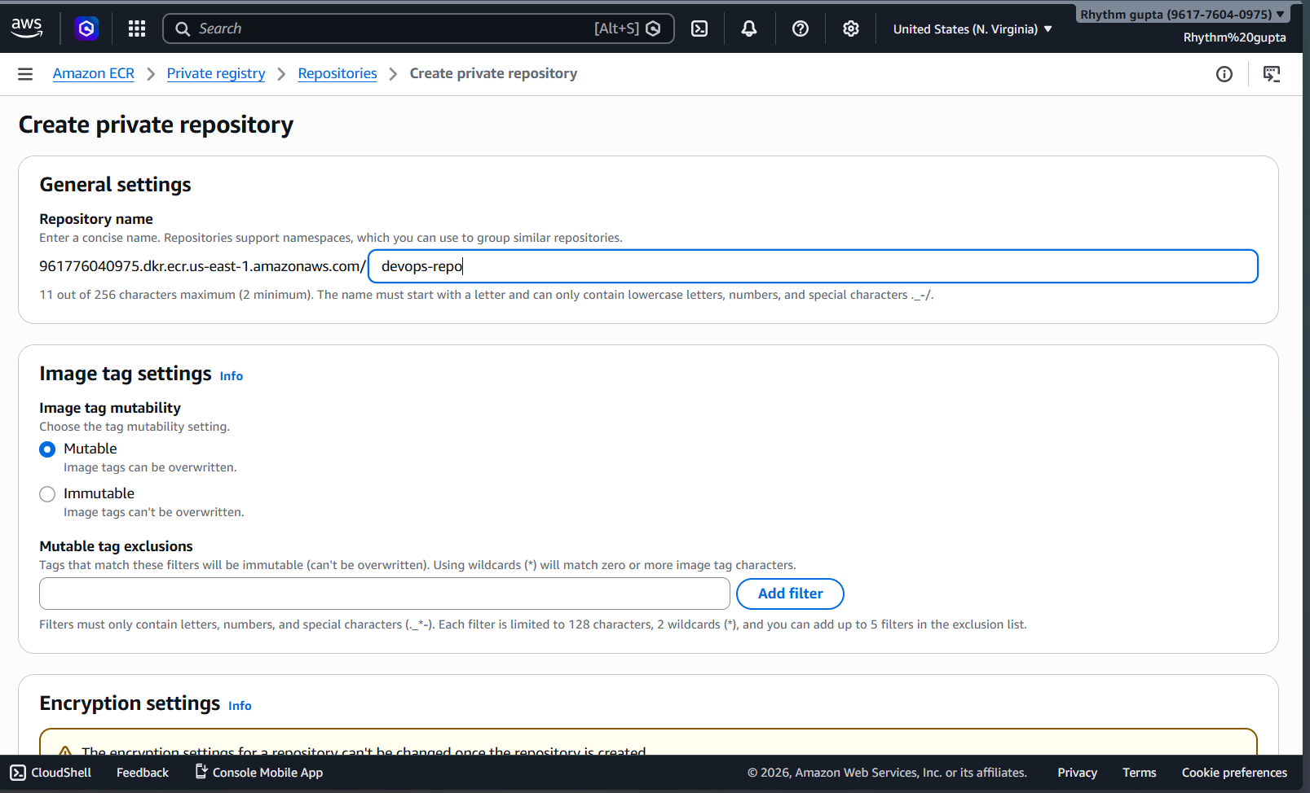

Step 2: Configure aws
Create access key
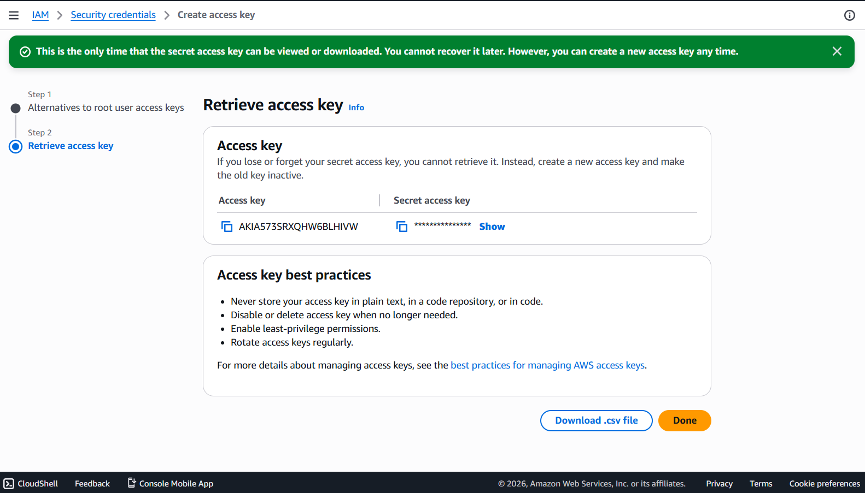

Step 3: Authenticate Docker to ECR
Run this :
aws ecr get-login-password --region us-east-1 | docker login --username AWS --password-stdin 961776040975.dkr.ecr.us-east-1.amazonaws.com

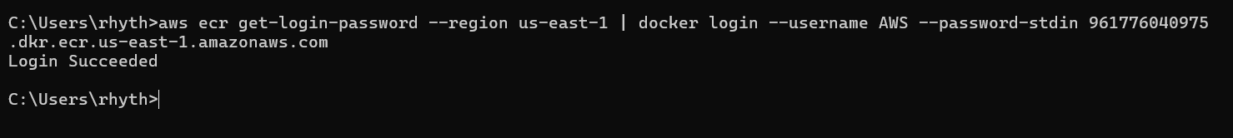
Step 4: Build Docker Image
Run this :
docker build -t devops-repo .

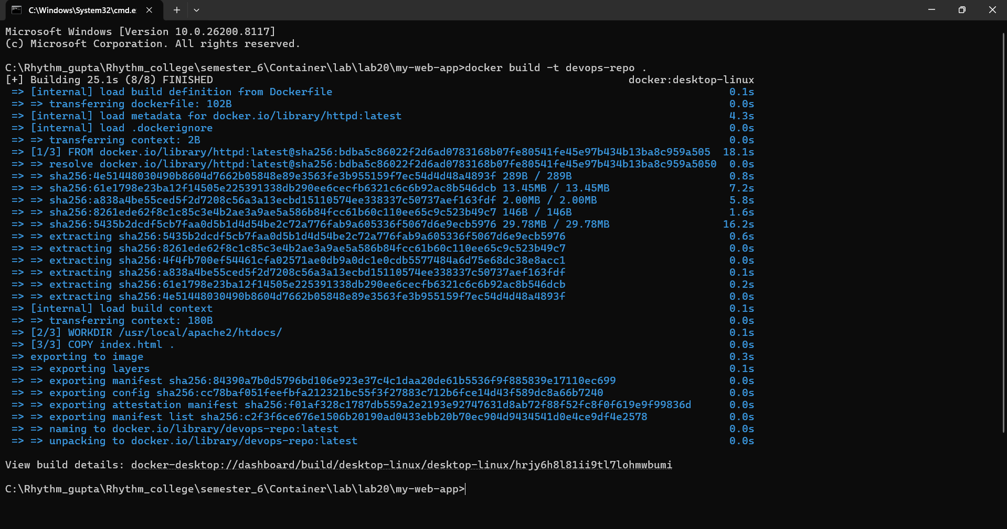
Step 5: Tag Docker Image
Run this :
docker tag devops-repo:latest 961776040975.dkr.ecr.us-east-1.amazonaws.com/devops-repo:latest

Step 6 : Push Docker Image
Run this :
docker push 961776040975.dkr.ecr.us-east-1.amazonaws.com/devops-repo:latest

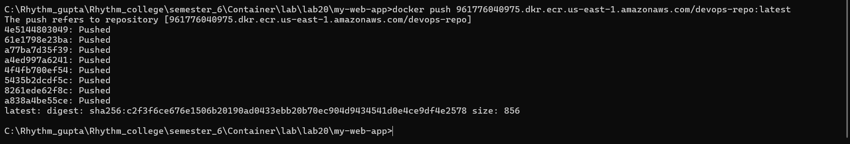
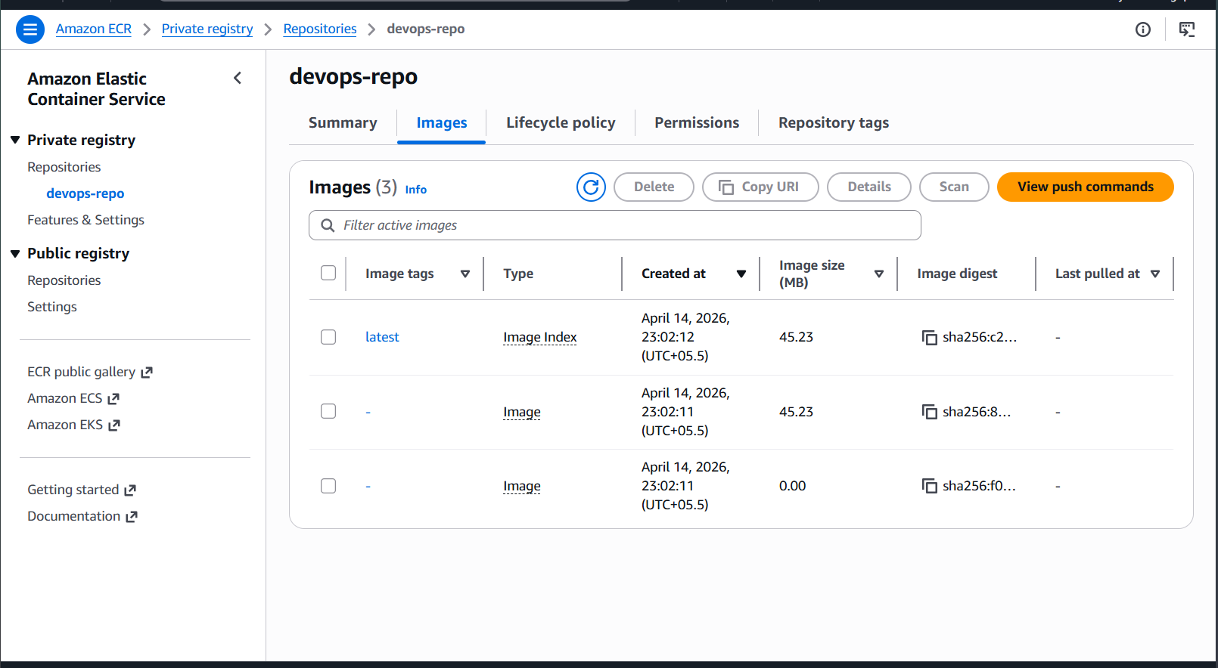

Step 7: Create Cluster
- Go to ECS
- Click Create Cluster
- Select Fargate (Serverless)
- Cluster Name: devops-cluster-new
- Click Create

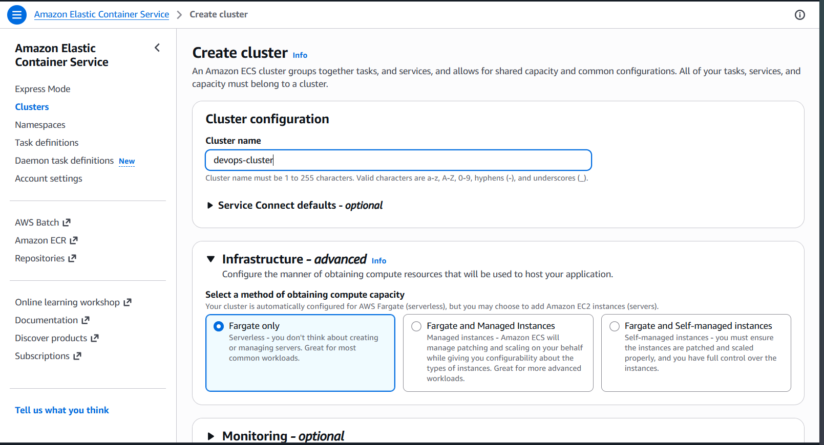

Step 8: Create Task Definition
- Launch Type → Fargate
- Container Image → Paste ECR URI

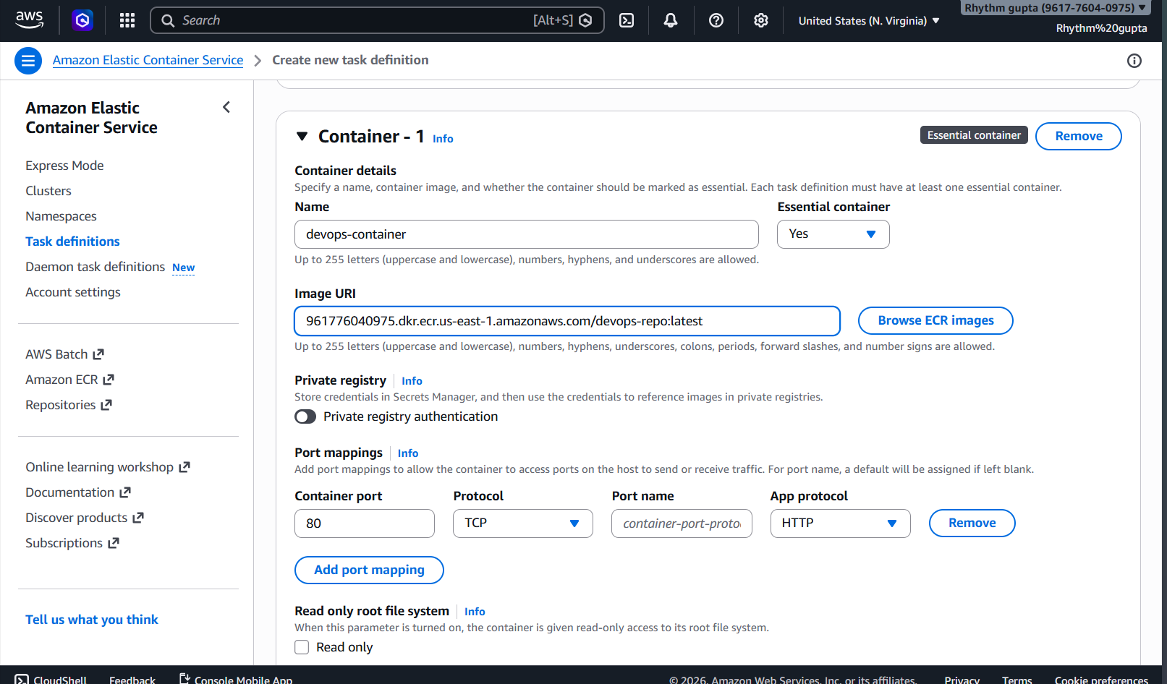

Step 9: Create Service
- Go to Cluster
- Click Create Service

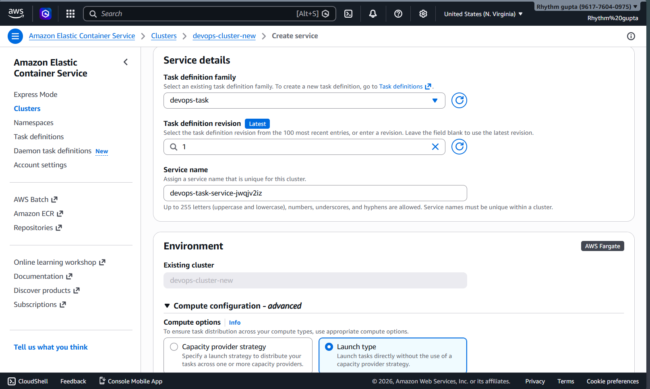

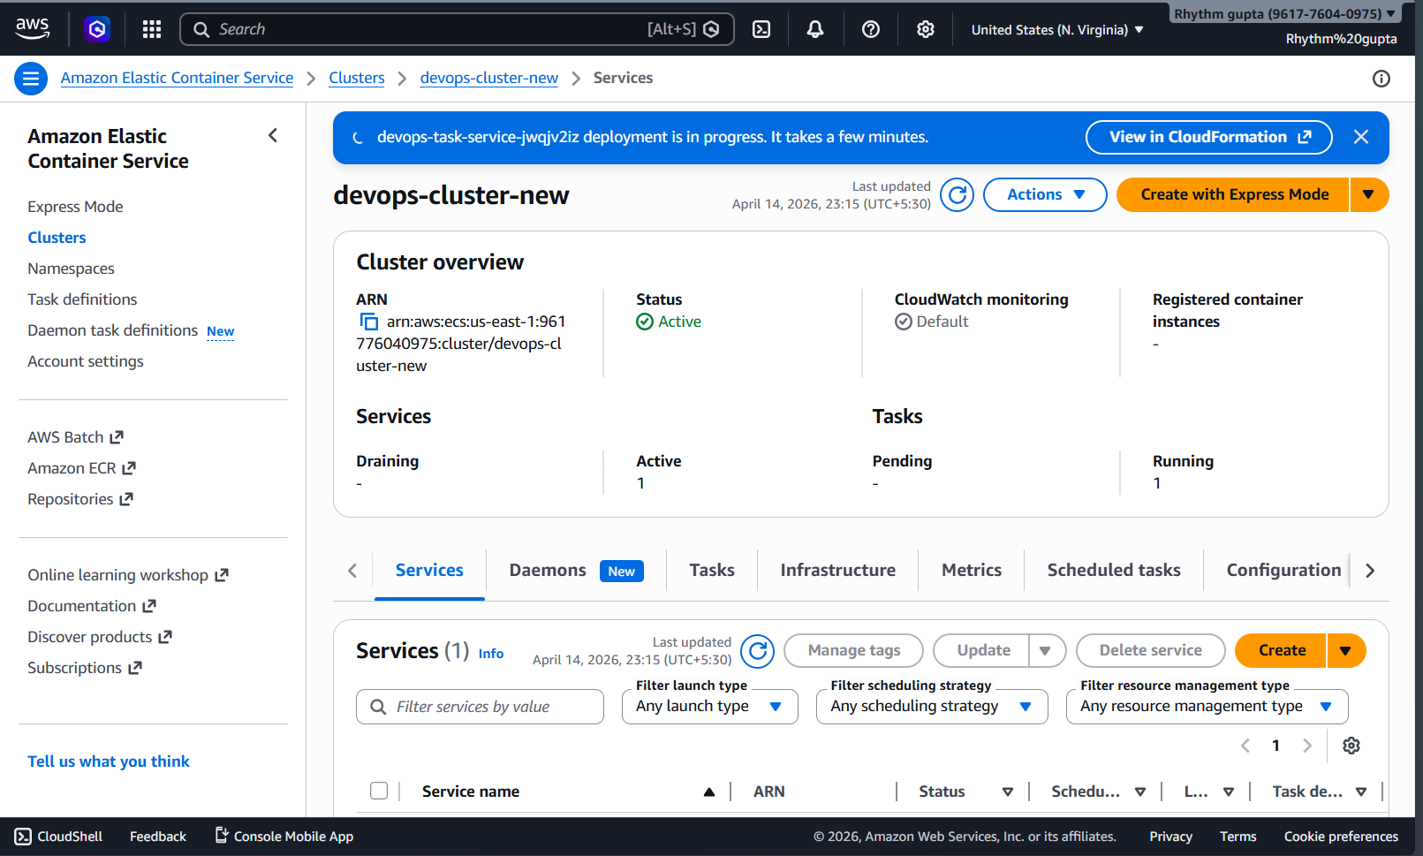

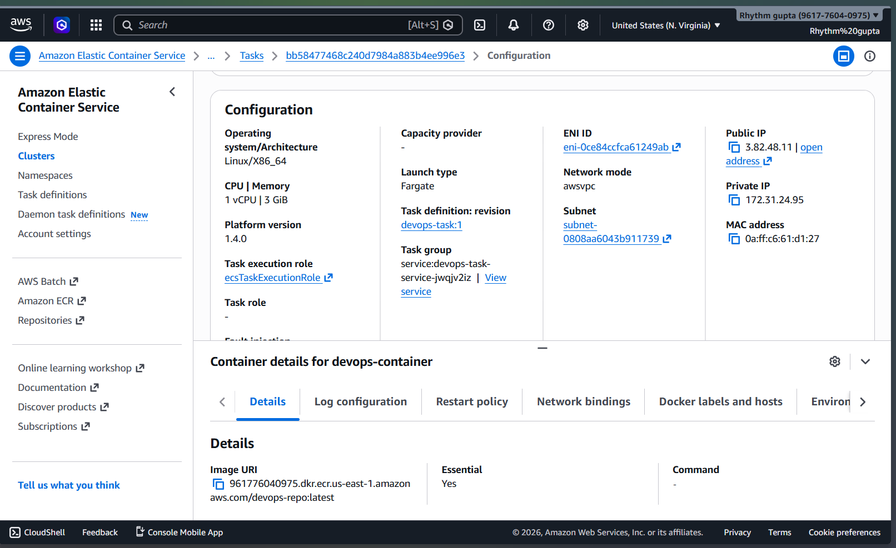Step 10: Turn on all traffic in security broke
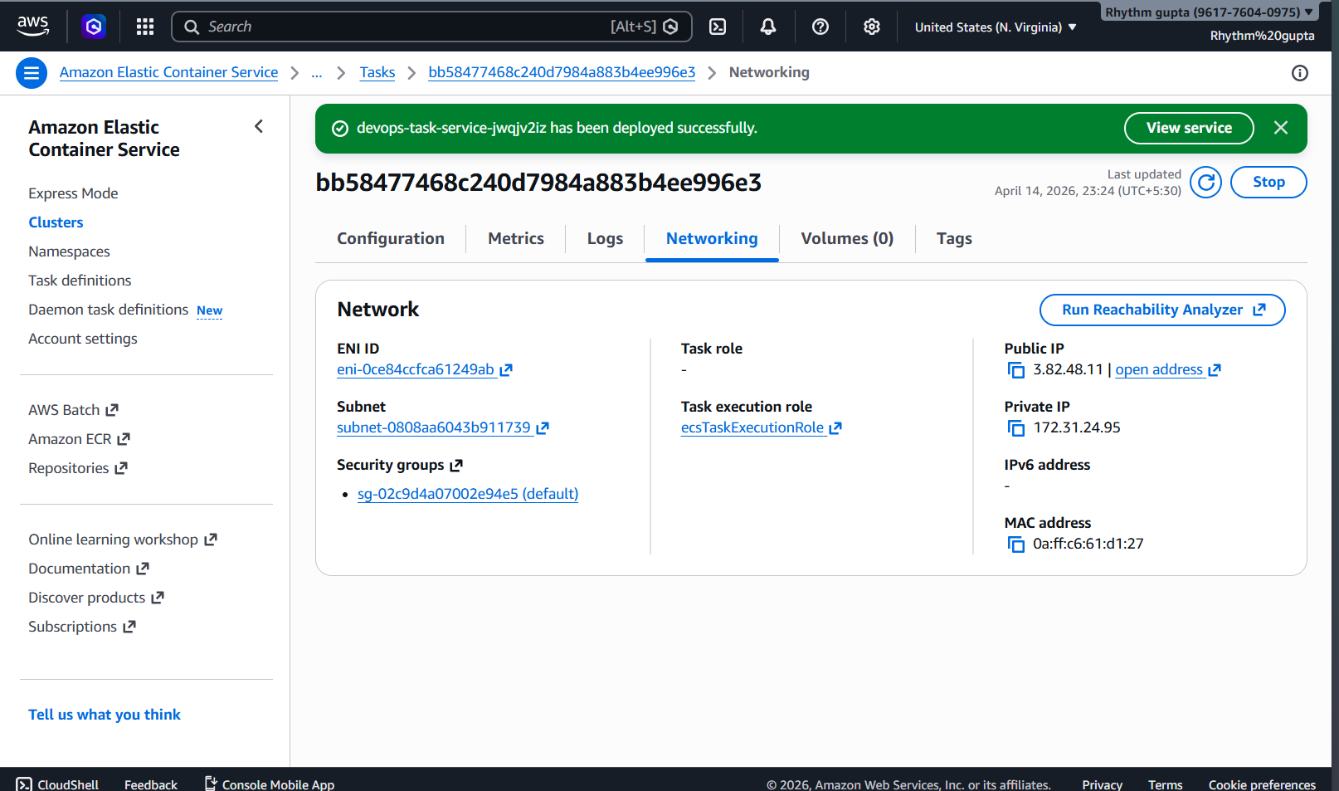
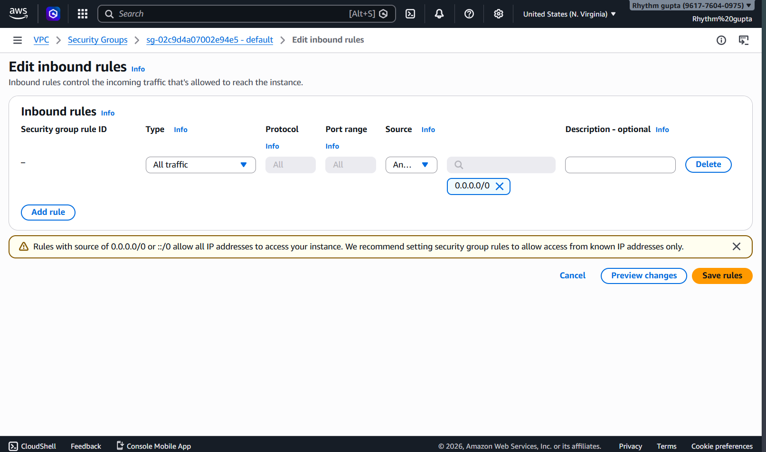

Step 11 : Verify Deployment
- Go to Load Balancer
- Copy DNS Name
- Paste in Browser

